Connection tester

NICE 1.0

Product manual

Revision | Comment | Date
1.0 | Initial version. Log file format information missing. | 14.11.08
1.0.1 | Added self test, maintenance topic. | 19.11.08
1.0.2 | Updated self test topic. | 3.2.09

Table of contents

- Hardware
- Measurement Principle
- Firmware
  - Boot Mode
  - Normal Mode
    - PC Packet
    - Card Response Packet
    - Command Set
- Test Program Description
- Configuration File
- Test File
- Test Program
  - User Interface Description
  - Self test
  - Maintenance
- Usage
- Troubleshooting

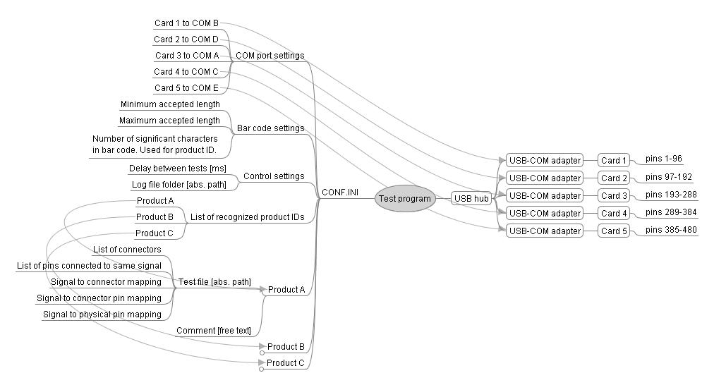
Drawing 1. Simplified test system structure.

1 Hardware

Connection tester consists of five measurement cards. Every card has 96 measurement pins and one serial communication (COM) port. Custom USB to COM adapter (utilizing FT232RL device) is used for interfacing the cards with PC. If PC does not have required number of available USB ports then USB hub has to be used. Connection tester is supplied with 7-port USB hub.

Note. Every card draws around 400mA of current from USB port. USB standard requires USB port to supply at least 500mA of current and to have a current limiter. Not all devices fulfill these requirements. For example there may be no limit for the USB output power and in case of short circuit PC main board may be damaged. Also maximum total available power for all USB ports may be limited thus violating the 500mA requirement. Please make sure that Your PC complies with the standard when not using supplied USB hub.

There are two ways to properly power on the system using USB hub:
- Connect all cards to USB hub. Connect power plug to USB hub. Connect power adapter to mains outlet. Connect USB cable between PC and hub.
- Connect power plug to USB hub. Connect power adapter to mains outlet. Connect USB cable between PC and hub. Connect measurement cards to USB hub waiting some seconds between each card. Windows can get confused when new COM ports are added in rapid succession and new port is added before old ones are configured properly.

NB! Make sure that USB cable between PC and hub is always disconnected before unplugging power to USB hub. Failure to do so results in power being drawn from PC causing overload.

2 Measurement Principle

Every pin has output current of about 20mA when driving high and 10mA when sinking low. If two or more pins are connected together then higher current will “win”. This will force the low driving pin high and software can detect that there is a connection. Connection types fall in 3 main categories:
    - Pin not connected. All pins are configured as outputs. The pin in question is driven low and all the rest are driven high. If there is a connection to somewhere then the low driven pin is read back as high and test fails.
    - Connection. All pins are configured as outputs. The pin in question is driven low and all the rest are driven high. If the pin is not connected anywhere it will read back as low and test fails.
    - Shorts. One pin in the signal group is driven low. Other pins in the same group are configured as inputs. Rest of the pins are configured as high outputs. If the signal is shorted to anywhere then all the signal pins will read back as high and test fails.
It logically follows that if normally not connected pin is shorted to somewhere then there is no point to continue testing because it will give more errors later confusing the root cause. Also when in Connection test it is discovered that some pins are not connected to anywhere then Shorts test can give false results due to the nature of the measurement principle. Follow the golden rule: “First error is the correct one”.

NB! This measurement principle does not tell which signals are shorted together. It only tells which signals are shorted to somewhere giving hints. It remains up to the troubleshooter to clarify.

3 Firmware

All connection tester cards run identical firmware. Windows driver makes use of the unique serial number in FT232RL for differentiation among cards. Communication baud rate is 115200 bps. Cards have two operating modes: boot and normal mode. After powering up the card waits for the communication to start. Upon receiving first byte a two-second boot timer is started. Every new byte resets the boot timer. If a boot mode command is executed then command timeouts increase the boot timeout.

3.1 Boot Mode

Boot mode commands consist of single bytes:
- 0x00 = poll. Response is 0x01. If this command has not been executed after idle time of two seconds then card boots into normal mode.
- 0x01 = get flash ID. Response is 0x01 followed by ID. Timeout of 1 second applies.
- 0x02 = program. Response is 0x02. Timeout of 1 second applies. After receiving the response the whole boot program can be sent. The delay between individual bytes may not be greater than 100ms. Card sends response 0xFF when program has been internally written and it is ready for new commands. Timeout of 10 seconds apply (starting from the receiving of the last byte).
- 0x03 = erase. Response is 0x03 noting the start of erase cycle. Timeout of 1 second applies. 0xFF notes the end of the erase cycle. Timeout of 20 seconds applies.
- 0x04 = read. Response is whole saved boot program. This can take up to 40 seconds.

NB! Card needs to be polled constantly so that it stays in boot mode unless some command is being processed.

3.2 Normal mode

If boot timer expires (see chapter “Firmware”) then normal test mode is initiated automatically. Test program initiates normal mode by executing “Read Status” command after every four seconds.

Firmware responds to commands from the test software and drives measurement pins. There are total 9 commands. Commands together with parameters are wrapped inside packet when sent by PC. Card responds with plain data without any error checking. When card powers up and exits boot mode it does one-time initialization that affects rest of its operation
FPGA is loaded and FPGA status is updated in status register.
Simple self test is made:
- All pins are configured as outputs.
- All pins are set to high level.
- Check is made that no pin is stuck in low level.
- All pins are set to low level.
- Check is made that no pin is stuck in high level.
Communication is initialized.
If self test is made with measurement cards connected to the product and some cards are not powered then self test will fail due to active cards failing to drive high the pins that the product connects to non-powered card. Also when these cards eventually are powered then previously powered cards remain in “all-pins-high” mode and the effect is the same.

NB! Always disconnect measurement cards from the product before powering on the system.

3.2.1 PC Packet
This is the format used for communication by PC.

Table 1. PC packet.
1) Start Byte
Constant. Always 0x55.

2) Command
See Table 3.

3) Parameter lengths
Hex number 0xAD, where A is address length in bytes and D is data length in bytes. Legal values are 0 to 4.

4) Address
Some commands have address parameter. Higher byte is sent first. See Table 3.

5) Data
Some commands have data parameter. Higher byte is sent first. See Table 3.

6) CRC
Is used for error checking. Calculated as follows:
CRC=Start byte+Command+Parameter lengths+(Each Address byte)+(Each Data byte)+1

Every byte is increased by 5 before sending out. CRC is calculated before this addition. Measurement card decreases every received byte by 5 before using it. This ensures, that most of the bytes are greater than 0x05 meaning that they cannot be accidentally interpreted as boot commands

3.2.2 Card Response Packet

Table 2. Card packet.

1) Data
Higher byte is received first. See Table 3.

3.2.3 Command Set

Table 3. Command set. N=none, B=byte, D=double integer (4 bytes).

- Read Status
Return value 0xSF.
S - Initial power up self test result.
1=Fail
0=Pass
F - FPGA status.
1=Loaded
0=Error

- Read Test Program *
Returns test program data specified by address parameter.

- Write Test Program *
Writes test program data to the specified address. Card returns status – 255 denotes success and 0 indicates an error.

- Set Test Program Counter *
Sets current test step pointer to the specified address. Card returns status – 255 denotes success and 0 indicates an error.

- Read Current Test Step Result
Result is one byte and in binary it is interpreted as 0bXXXXXABC, where
X=not used, always 0
A,B and C denotes sub results:
= 1 Difference with expected results.
= 0 Test results are as expected.

- Read Current Test Step Difference A
Returns error bits for pins 1 to 32. Refer to Test Program description.

- Read Current Test Step Difference B
Returns error bits for pins 33 to 64. Refer to Test Program description.

- Read Current Test Step Difference C
Returns error bits for pins 65 to 96. Refer to Test Program description.

- Read Framing Error Count
Count of failed packets since last power up.

* Has burst mode
Address is incremented automatically when address parameter is not supplied within packet.

4 Test Program Description

One test step consists of 9x32 bits of data. The order of data is as follows:

Table 4. Register description.

- PORTxDR
Data registers for driven pin values. Logical hi or low corresponds to electrical high or low.

- PORTxDDR
Data direction register for pins. 1 – pin corresponding to bit position is set as output. 0 – pin is configured as input.

- PORTxCR
Comparison register holding expected pin levels. Test result is calculated as Current Test Step Difference x = actual states in PORTx XOR PORTxCR. XOR stands for exclusive or resulting in 1 in case of difference between expected and actual pin levels and 0 when they are the same.

5 Configuration File

Test program needs several configuration parameters that depend on the usage environment. These parameters are held in CONF.INI file that has to be in the same folder as TEST.EXE.

There are areas called sections with their names enclosed in brackets. Each section has set of data called keys. Keys can hold values of different type. Example follows:

[Serial_code]
Length_min=5
Length_max=8
Significant=15
[Control]
Frequency=5
LOG=C:\Result
[Products]
EE003=""
EE004=""
EE005=""
[EE003]
TestFile=C:\Data\EE003.ini
Comment=12V version
[EE004]
TestFile=C:\Data\EE004.ini
Comment=24V version
[EE005]
TestFile=C:\Data\EE005.ini
Comment=5V version
[Serial]
CARD1=COM13
CARD2=COM14
CARD3=COM15
CARD4=COM16
CARD5=COM17

- Serial_code – is used mainly for sorting out bar code read errors. It is possible to set minimum and maximum length of accepted bar code. Another function is to recognize product type so that correct test program could be loaded. This is done by looking at first part of bar code. This significant part length is set in this section.
- Control – here is set test result log path and test frequency. Test frequency means number of tests in second. Key “Frequency” holds delay value between tests in milliseconds. Higher number means longer delay. Its main purpose is to fine-tune test program performance to match it better with test PC capabilities.
- Products – list of recognized bar code subsets (keys for this section). The keys themselves do not hold any particular value. For each entry there must be corresponding section holding additional information:
  - TestFile – absolute path to product's test file
  - Comment – info to be displayed on user screen. Its purpose is to help user in identifying mis-labeling.
- Serial – each cards' corresponding windows communication port number.

6 Test File

Its format is same as with configuration file meaning there are sections and keys. Special sections are:
- CONNECTORS – connector names are indexed. Pin info is formatted as (connector index)+(pin name in connector).
- NC – not connected pins. These pins do not have any particular signal name so they are grouped together here but test program does not require them to be connected together as is the case with other signal groups.
- IGNORE – impossible tests. Tests that cannot be done are not done. The reason is related to diodes in product. The test number to be ignored is number before ignoring – all tests are renumbered when some are removed in between.
All other sections are signals. All the pins in the signal group are connected together and not connected to anywhere else. If there is only one pin in the group then it is treated as NC pin but keeps its signal name.

NB! It may be that some signals are not actually connected together according to schematic but are still tested as one large connection group in test program. This is necessary due to parasitic connections caused by components on board. Mostly these are power signals that are tested more thoroughly in functional test.

7 Test Program

Test program is implemented in LabVIEW 8.0 graphical programming language. LabVIEW 8.0 Runtime must be installed on the computer before test program executable TEST.EXE can be used. Make sure that proper CONF.INI file is in the same folder as TEST.EXE.

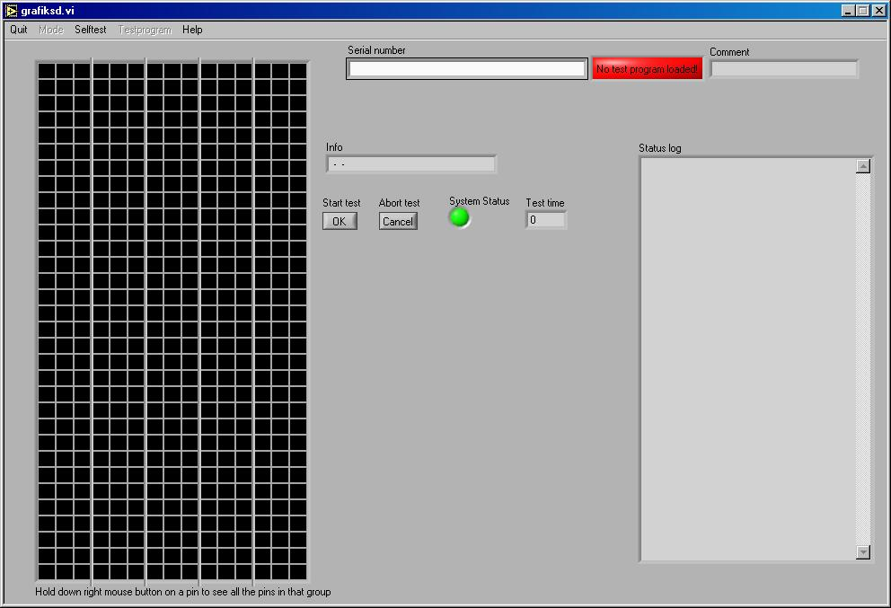
Drawing 2. Test program screen shot.

7.1 User Interface Description

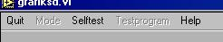
- Menu. Has three selectable items:
  - Quit – exits application without waiting the completion of test.
  - Selftest – displays power on self test result. Additional help information display opens.
  - Help – turns on and off interactive help feature. To get help on particular item just turn on help feature and hover mouse cursor above item in question.

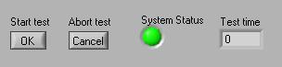
- Test controls and indicators:
  - Start test – works in parallel with “Enter” key. Bar code reader has to be configured to output Carriage Return after reading valid bar code so that testing would automatically start. If system is not ready then this control is disabled.
  - Abort test – cancels current test. Log file is not saved if test is canceled before end.
  - System status – indicator showing communication status. Testing can start only when status is green.
  - Test time – test time in seconds.

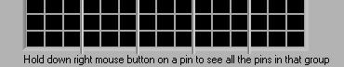
- Main indicator. Displays information such as communication, self test result, pin connections, test type and test step result. All information is color-coded. Every card uses 3 x 32 rectangles to display its relevant data.

Table 4. Pin mapping on main indicator.

- Product specific. Serial number is used to tie every product to particular log files. Serial numbers are usually read from the product with the help of bar code reader. Colorful indicator shows the status of PC memory. No pin info is available or tests possible without loading test program. Test program is loaded only after successful decoding of serial number to product type. Testing is impossible with faulty bar codes. Comment field content is read from CONF.INI after resolving product type. Its purpose is to help user in identifying the correct product.

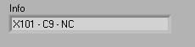
- Pin information. Available only after test program is loaded. Hover cursor over pin in question to get connection information. Format is X – Y – S, where:
  - X – connector name.
  - Y – pin name in connector.
  - S – signal name according to schematic.

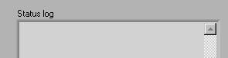
- Log window. Shows last completed test result. The content is updated only after end of test session meaning that interrupted test results are not shown.

7.2 Self test

Select “Selftest” from the menu to see self test information. Test itself is made during power-on initialization. Selecting “Selftest” from the menu only displays the results. Information is displayed in columns:

Red column - communication lost. May happen during card initialization process so wait for 60 seconds and if nothing happens then unplug card from the hub and connect it back after 10 seconds. If this does not help then please check CONF.INI and COM port settings in Windows Device Manager.

Pink column - card did not boot correctly and cannot be used for testing. This may happen due to electrical disturbance. Unplug card's USB cable and connect it back after waiting 10 seconds

Yellow column - power-on self test failed. Testing can still continue because failing may have been caused by human error - card's measurement pins must not be connected anywhere during powering up and initialization. Unplug card from hub and product, wait 10 seconds, plug it back to hub and wait for result.

Green column - power-on self test passed.

NB! Power-on self test discovers only functional errors caused by malfunctioning measurement hardware. Visual inspection is needed to find problems associated with broken and bent pins or with foreign objects shorting the pins.

7.3 Maintenance

Only user serviceable parts of the system are:
- Communication cable.
- Measurement pins.
Cable. Replace the cable when internal wires become visible. Failure to do so can lead to shorting out of USB power – this in turn can cause damage to PC main board.
Pins. Pins can get bent when measurement cards are pulled out from one corner. Bent pins are likely to bend even more when re-inserting the card so care must be taken that pins are always straight. The connector is not replaceable without special tools. Whole internal card together with connector has to be replaced.

8 Usage

- Connect system to the PC as described in Hardware topic.
- Start TEST.EXE. Test program starts and initializes test system.
- Wait for the test program status indicator to blink green. System is ready.
- Connect measurement cards to the product.
- Scan bar code. Testing starts.
- Test ends. See test log for result. Mark defective boards for later inspection.
- Disconnect measurement cards from the product. Use extra care when disconnecting cards so that measurement pins would not get damaged.

9 Troubleshooting

Possible software issues:
- Test program needs LabVIEW 8.0 runtime to be installed on the test PC in order to function.
- Windows has to recognize USB – COM converters. COM numbers in Windows Device Manager have to match COM numbers in CONF.INI.
- CONF.INI has to be in the same folder as TEST.EXE.
- Paths to test files in CONF.INI have to be absolute paths.

Possible hardware issues:
- USB hub power adapter is disconnected. PC may not have enough power to supply the system reliably.
- USB cable has became loose. Make sure that all connectors are inserted fully.
- USB cable is damaged. Most probable when irregular communication losses occur during inserting and disconnecting of measurement cards.
- Damaged pins. Bent and missing pins are a problem. These failures do not become apparent if they happen to match with electrical connections. Inspect visually from time to time.
- Internal failure. See if self test passes. Replace the card with spare and modify COM port numbers in Windows Device Manager to match with the replaced card's.

